
SYNOPSIS

Report on

YouTube Clone

By

PRASHANT GUPTA, Roll No : 2200290140113

Session: 20232024 (III Semester)

Under the supervision of

MRS. KOMAL SALGOTRA (Assistant Professor)

KIET GROUP OF INSTITUTIONS, DELHI-NCR, Ghaziabad

DEPARTMENT OF COMPUTER APPLICATIONS

KIET GROUP OF INSTITUTIONS, DELHINCR,

GHAZIABAD201206

(20232024)

Page 1 of 10


ABSTRACT

In the digital age of video content, NextTube emerges as a pioneering video sharing platform, set to revolutionize the way we interact with and consume online media. NextTube is not just a YouTube clone; it's an evolution, designed to empower creators and engage audiences like never before.

Key Features:

1. Seamless Video Upload: Creators can effortlessly upload and share their videos, with support for various formats and resolutions.
2. Intelligent Recommendation Engine: NextTube cutting edge AI driven recommendation system ensures that users discover content tailored to their interests.
3. Enhanced Creator Tools: A comprehensive suite of creator tools, including analytics, monetization options, and audience engagement features, enables creators to thrive.
4. Community Building: Foster connections and engagement with your audience through comments, likes, shares, and live streaming.
5. Adaptive Streaming: Enjoy smooth, buffer free playback with adaptive streaming technology.
6. Content Categories: Browse a vast array of content categories, from educational to entertainment, catering to a diverse audience.
7. Mobile App: Take NextTube on the go with our intuitive mobile app, available on both Android and IOS.
8. Privacy and Safety: Robust content moderation and privacy settings ensure a safe and welcoming environment for all users.

NextTube is not just about video sharing, our vision is to empower content creators to unleash their creativity and connect with audiences worldwide. We believe that by providing a platform that prioritizes quality content, user engagement, and safety, we can elevate the online video sharing experience to new heights.

Join us on this journey as we redefine the way you watch, create, and share video content. Welcome to NextTube, where the future of online video begins.

Page 2 of 10

CONTENTS

- Introduction Of Project

- Literature Review

- Objective Of the Project

- Research Methodology

- Project Outcome

- Proposed Time Duration

- References

Page 3 of 10
- INTRODUCTION

In an era where the digital world reigns supreme, video content has become the universal language of expression, entertainment, and education. With billions of Users worldwide hungry for diverse and engaging videos, the demand for a dynamic video sharing platform has never been greater. NextTube, not just as another YouTube clone, but as a visionary project poised to redefine the landscape of online video sharing.
Viewers seek a space where they can discover, engage with, and share content that resonates with their passions and interests.
We're building an environment where viewers can seamlessly explore a vast sea of content, discover new perspectives, and connect with likeminded individuals from around the world.

Our commitment to innovation extends to our robust infrastructure, from advanced video streaming technology to intelligent recommendation algorithms.
we'll create a platform where imagination knows no bounds, where creativity knows no limits, and where the world comes together through the magic of video.

Welcome to NextTube. Welcome to the future of online video.

Page 4 of 10
2. LITERATURE REVIEW

A literature review for a YouTube clone project would involve summarizing relevant academic or industry research, articles, and studies related to video sharing platforms, online video trends, user behaviour, and technology. Here's a sample literature review section for your project:

1. Evolution of Online Video Sharing Platforms
As these platforms have grown in popularity, they have become not just entertainment hubs but also educational and informational resources. Understanding this evolution provides valuable insights for developing a YouTube clone that meets contemporary user expectations.

2. User Behaviour and Engagement on Video Sharing Platforms
Research into user behaviour on video sharing platforms is pivotal in shaping platform design and content recommendations. Studies have shown that viewers engage more with content that aligns with their interests. Moreover, audience engagement through likes, shares, and comments contributes to a sense of community. For a YouTube clone, optimizing user engagement mechanisms is essential for long term success.

3. Technological Advancements in Video Streaming
The advancement of video streaming technologies has played a significant role in the user experience of online video platforms. Adaptive streaming, in particular, has become integral in delivering smooth playback experiences across various devices and network conditions. These technologies are essential components of any YouTube clone aiming to deliver high quality video content seamlessly.

In conclusion, a comprehensive review of literature in the field of online video sharing platforms provides essential insights for the development of a YouTube clone.

Page 5 of 10
3. OBJECTIVE OF PROJECT

The objectives of a YouTube clone project would depend on your specific goals and vision for the platform. However, here are some common objectives that you might consider when undertaking such a project:

1. Platform Development:
Create a functional and user friendly video sharing platform that mimics the core features of YouTube, including video uploading, playback, comments, and user profiles.

2. Innovation and Differentiation:
Introduce unique and innovative features that set your YouTube clone apart from the original platform, offering users something new and exciting.

3. User Engagement:
Foster a vibrant community of content creators and viewers by implementing engagement features like likes, shares, comments, and subscriptions.

4. Content Quality Control:
Implement content moderation and quality control measures to ensure that the platform is safe, free from harmful content, and suitable for users of all ages.

5. Recommendation System:
Build an intelligent recommendation algorithm that helps users discover content tailored to their interests, enhancing user retention and engagement.

6. Scalability:
Design the platform to handle increasing user traffic and content uploads while maintaining performance and reliability.

7. Global Reach:
Aim to attract a diverse global audience by offering content in multiple languages and catering to various cultures and interests.

8. Creator Support:
Provide a comprehensive suite of tools and resources to support content creators, including analytics, copyright protection, and promotional features.

9. Community Building:
Cultivate a sense of community among users and creators by facilitating interactions and collaborations.

10. User Education:
Educate users about responsible content creation and consumption, digital literacy, and online safety.

These objectives should align with your overall vision for the YouTube clone and serve as a roadmap for its development and growth. Keep in mind that the success of your project will depend on your ability to execute these objectives effectively and adapt to evolving user needs and industry trends.

Page 6 of 10
4. Project Methodology

Creating a YouTube clone is a complex project that involves multiple phases and tasks. Here's a step by step methodology to guide you through the development process:

1. Project Planning and Scope Definition:

Define Objectives: Clearly state the purpose and goals of your YouTube clone project. Understand what you aim to achieve with this platform.

Target Audience: Identify your target audience and their preferences. Consider whether you are building the clone for a specific niche or a broader audience.

Scope: Determine the scope of your project, including the core features and functionalities you want to replicate from YouTube.

2. Market Research and Analysis:

Trends and Emerging Technologies: Stay updated on industry trends, emerging technologies, and user behaviour related to online video sharing.

3. Design and Architecture:

UI/UX Design: Design the user interface (UI) and user experience (UX) of your YouTube clone. Create wireframes and mock ups to visualize the design.

4. Technology Stack Selection:

Choose the appropriate technologies and programming languages for both frontend and backend development, considering factors like scalability, security, and performance.

5. Testing and Quality Assurance:

Ensure cross browser and cross device compatibility.

6. User Education and Support:

Provide resources and support for users and content creators, including FAQs, and community forums.

Following this methodology will help you build a YouTube clone that meets user expectations and industry standards while allow for flexibility and adaptability as the project progresses.

Page 7 of 10
5. Outcome of Project

The outcomes of a YouTube clone project can vary depending on the goals and execution of the project. Here are some potential outcomes and benefits that you can expect from a successful YouTube clone project:

1. User Engagement: With the right features and design, you can expect high user engagement. Users should be actively uploading content, subscribing to channels, liking, sharing, and commenting on videos.
2. Community Building: Successful YouTube clones foster the growth of a vibrant community of content creators and viewers who interact, collaborate, and form connections.
3. User Growth: As your platform gains popularity and users find value in it, you can expect continuous user growth, both in terms of content creators and viewers.
4. User Satisfaction: High user satisfaction, as evidenced by positive reviews, feedback, and user retention rates, is a key indicator of a successful YouTube clone.
5. Innovation and Differentiation: Depending on your unique features and innovations, your project may stand out from other video-sharing platforms, contributing to its success.
6. Continuous Improvement: Successful projects continue to evolve and improve based on user feedback and changing industry trends.

It's important to note that achieving these outcomes may take time and require ongoing effort. Building and maintaining a successful video-sharing platform is a significant undertaking, but with the right strategy, dedication, and user-focused approach, it can lead to a rewarding and impactful project.

Page 8 of 10
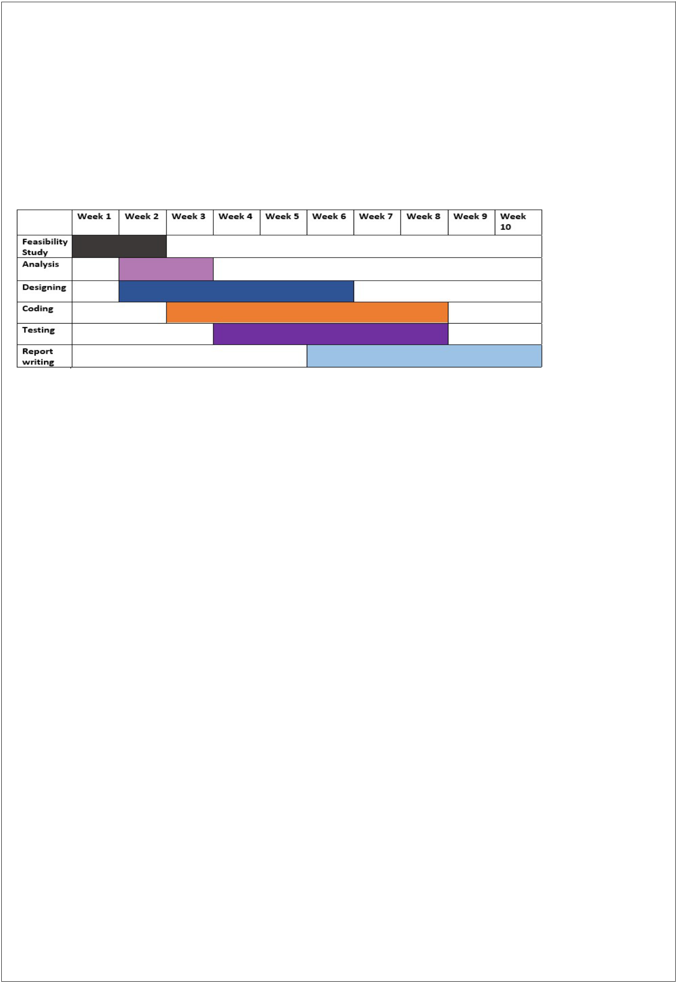
6. Proposed Time Duration

Gantt chart

Feasibility Study: We have decided 2 weeks for feasibility study and requirement gathering for that we can analysis our capabilities and resources.

Analysis: From 2 to 3 week, we proposed our self for esteem analysis of software requirements and risk and resource management.

Designing: In this phase (from 2 week to 6 week) we will focus on designing the blueprint of software and tries to focus on coding part also.

Coding: Form week 3" to week 8, we focus on coding part and tries to follow pre developed prototype of software.

Testing: Testing is not a part of only testing phase hence testing will be applied through each phase of software development life cycle.

Report Writing: During the process of developing project (software) we will constantly writes report on current project.

Hence the total time required to develop this project is around 10 weeks.

Page 9 of 10

7. References

Web Resources

www.java.sun.com

Official Java Website

www.java.sun.com/developer/onlineTraining/J2EE/Intro2/j2ee.html

Training for J2EE

www.java.sun.com/j2se/1.4.2/docs/api/index.html

J2SE Online Documentation from Sun

www.w3schools.com

JavaScript Tutorials

BOOKS

Java2 The Complete Reference(7TH Edition)
By: Herbert Schildt

JSP The Complete Reference By: Philhanna

Oracle 10g

By: Ivan Baross

Software Engineering

By: Roger Pressman

Page 10 of 10

